Derivation of Metric for Airtime Advance Revenue originating in USSD

**Introduction**:

* This metric indicates the summed value of Airtime Advance transactions which originate from the USSD channel.   
  Utilised on the USSD Executive dashboard, along with a baseline this view can very quickly indicate any issues that are affecting the bottom line.

**Prerequisites**:

* Appdynamics installation and configuration, data extraction and metric creation. Dashboard creation.

**Derivation Steps**:

1. **Step One**: Application agents installed on servers where the transactions take place. In this case Engineering Fusion VSA2 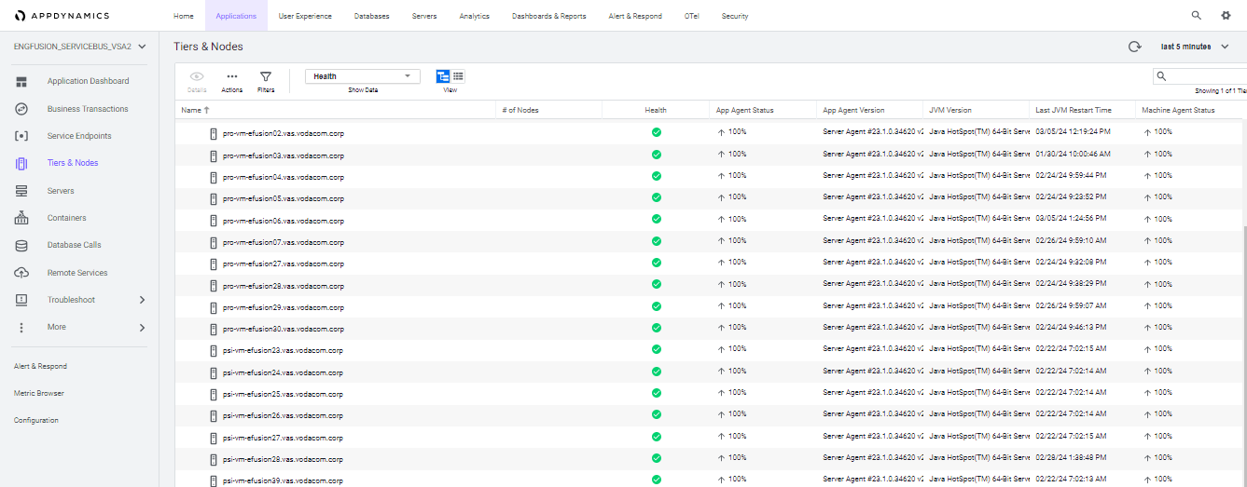
2. **Step Two**: Business Transactions are identified.

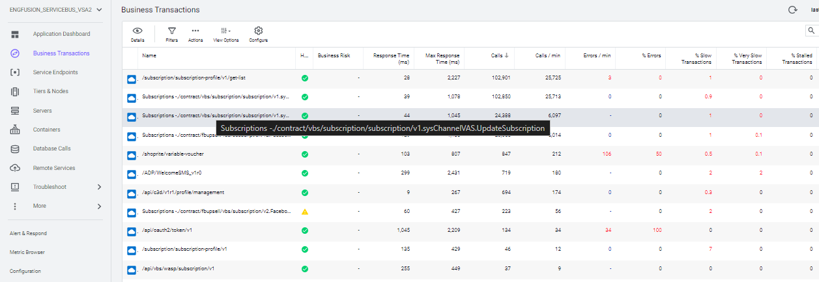

1. **Step Three**: The BT of interest is the point where FUSION is addressing the charging system to complete the Airtime Advance (CVAS) transactions -

Subscriptions -./contract/vbs/subscription/subscription/v1.sysChannelVAS.UpdateSubscription

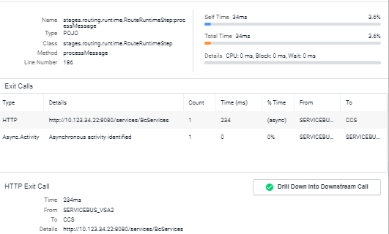

1. **Step Four**: Data collected from these transactions, essentially the “input”

For Class where name = stages.publish.runtime.PublishRuntimeStep

and where method = processMessage

Grabbing CHANNEL_ID & Amount out of Payload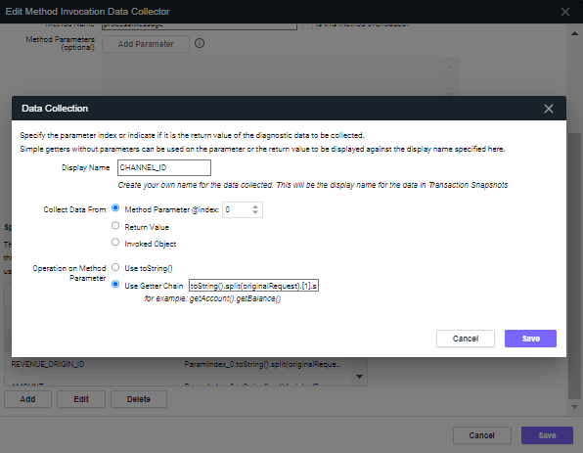

1. **Step Five**: This data is queried and stored as a metric with each Channel calculated separately

SELECT sum(toint(segments.userData.AMOUNT)/100) FROM transactions WHERE application = "ENGFUSION_SERVICEBUS_VSA2" and transactionName = "Subscriptions -./contract/vbs/subscription/subscription/v1.sysChannelVAS.UpdateSubscription" AND segments.userData.CHANNEL_ID = "*****"

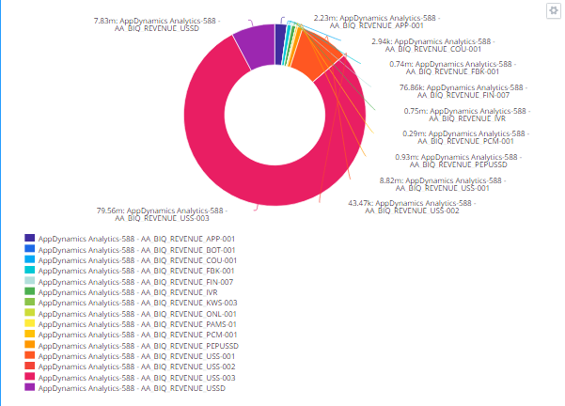

1. **Step Six**: USSD singled out for use on the USSD Executive dashboard –

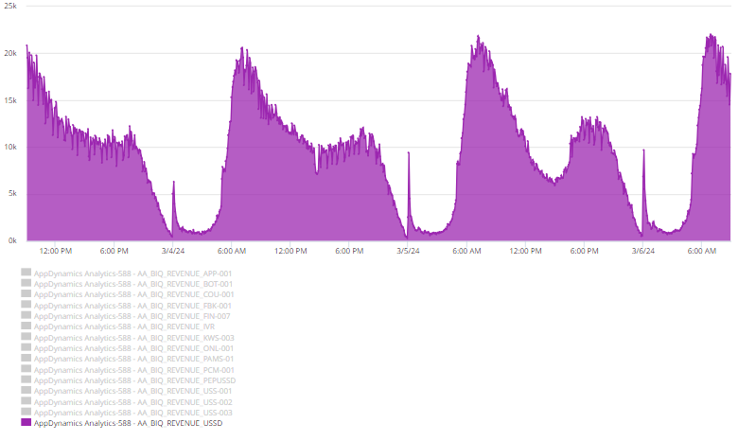

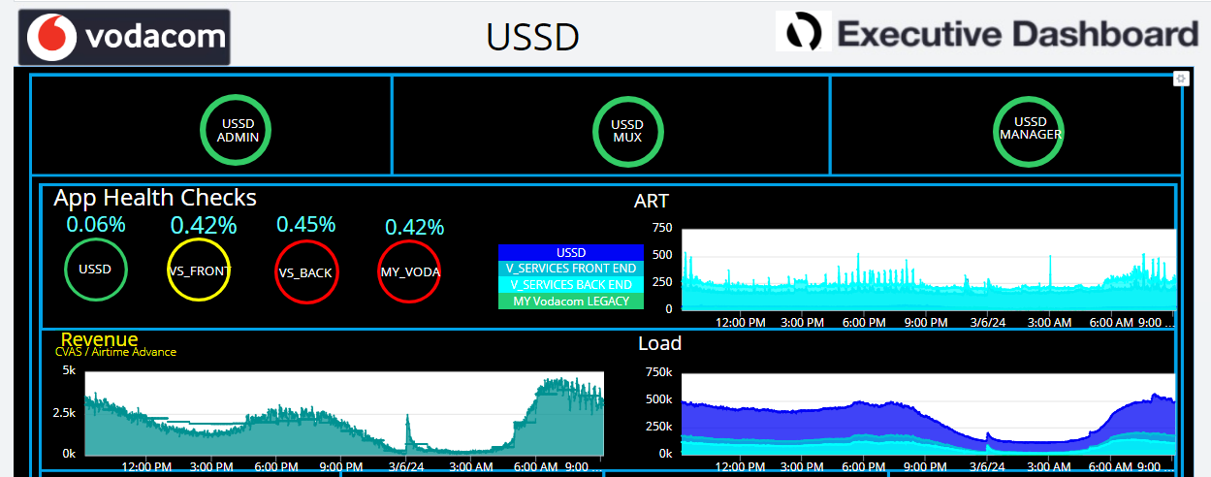

**Conclusion**:

* Sum of the relevant amounts in each Airtime Advance transaction, represented visually as a graph with a 30 - day baseline for trending.
* Closely monitoring this graph and deviation from the baseline will help to identify any issues quicker, but very importantly this is only a small portion of the USSD landscape and does not represent all the revenue for the application.